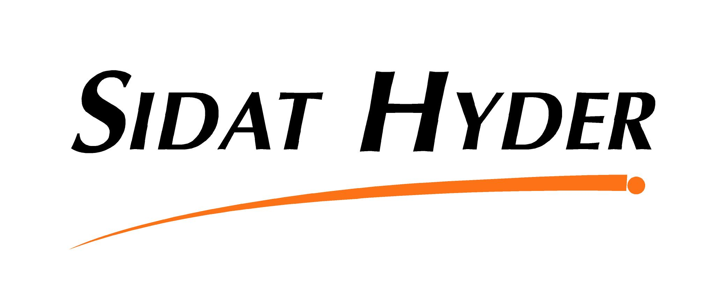 | 

COMPENSATION SURVEY 2007
REPLY FORM

Please fax this form to (92-21) 5685625 or e-mail at compensation.survey@sidathyder.com.pk

 | YES | NO
I would like to participate in the 2007 MEA Compensation Survey | ❑ | ❑

Company Name:
Mr. /Mrs. /Ms.:
Designation:
Company Details
Address:
Postal Code: City: Country:
Tel: Fax:
E-mail Address:
Nature of Business: …………………………… Website: ………………………………...

